# Preface

* Project goals
  + Streamline the acquisition of information or knowledge from the perspective of a user.
  + Organize information and curricula around existing bodies of knowledge from textbooks, videos, and slide shows.
  + Provide a generative tool for professors and students to produce high quality study guide questions in a local system.

# Building Knowledge Graphs

<https://arxiv.org/pdf/2009.11564.pdf> (Review, Machine Knowledge: Creation and Curation of Comprehensive Knowledge Bases)

* A more formal way of understanding a knowledge graph
  + Entity: Any abstract or concrete object of fiction or reality. (i.e. Shakespere, Macbeth, Diabetes, Emory Data Science Club)
  + Individual Entity: Is an entity that can be uniquely identified amongst all other entities.
    - Generally, this can be obtained by assigning an identifier which is a unique URL pointer to the entity.
  + A **mention** of an entity in a data source like text occurs when an acronym or a string is meant to denote an entity.
  + Entities can be organized into types or classes which are a group of entities that share a common trait–an element of that set is called an **instance**.
  + Like in biology, classes can hold taxonomies.
    - A is a subclass of B if all instances of A are in B.
    - Taxonomy can be represented as a directed acyclic graph. 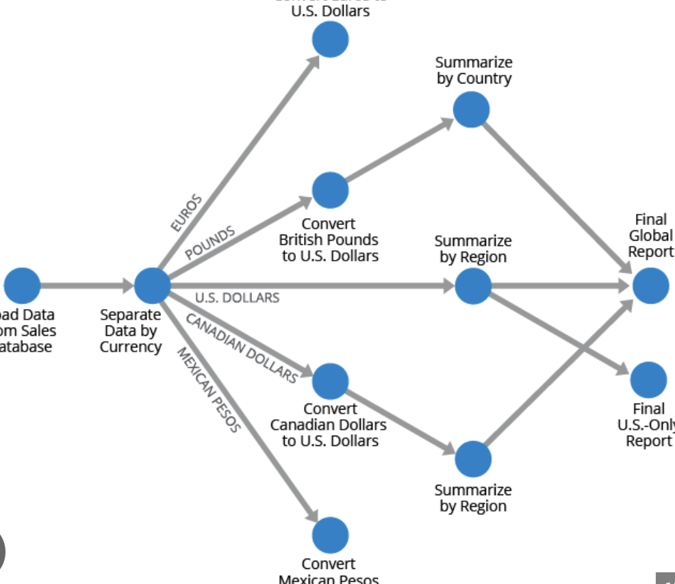
    - 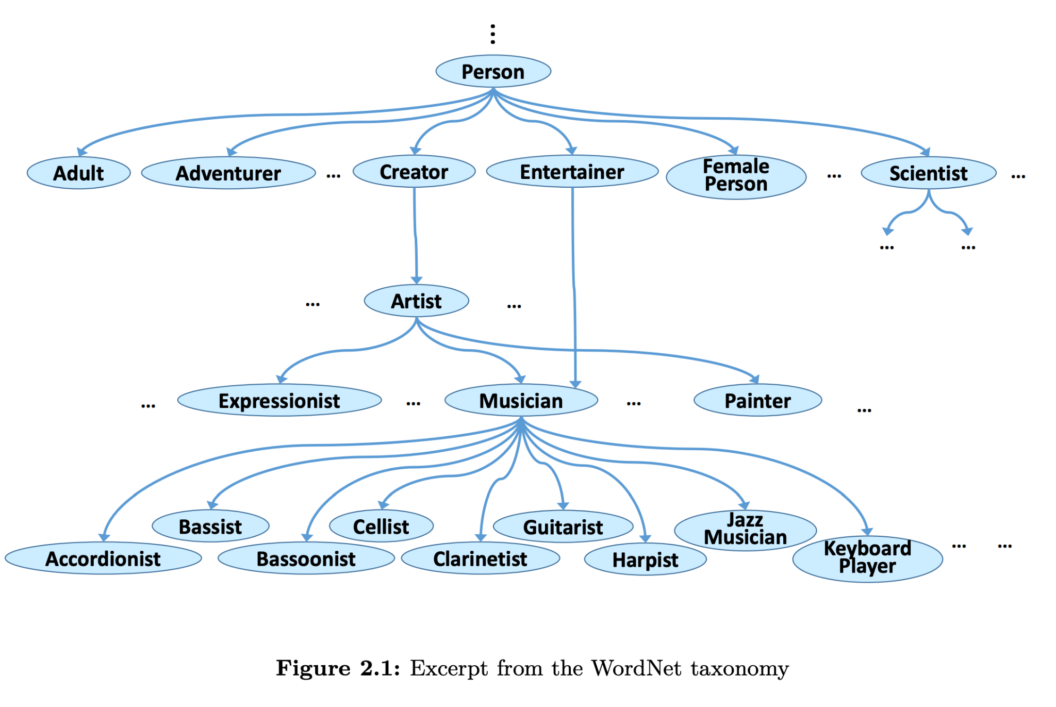
      * Established taxonomy databases do exist.
  + Cartesian product: 